Kellen Hunter

08/17/2020

IT FDN 110 A

Module 6 - Assignment 06

GitHub URL : <https://kbhunter5.github.io/ITFND100-Mod06/>

# Functions

# Introduction

Variables can be used to assign values within a function. The product or a sum would be an example of a Return value. This value can be stored and used later in a script. Functions are useful when coding scripts because they help separate procedures from each other, so they can be easily identified, manipulated removed. Global variables can be used inside or outside a function.

# Steps I took to perform this Assignment

First I, opened my script from assignment 5. I was able to copy and paste the necessary code into assignment 6. Next I, was able to start creating my functions and assign my variables in the “input/output” section of the script. Once the IO class was complete, I was able to move to the main body of script. Here is where I was able to call up the functions when a specific number between 1 and 5 was input. Finally, The text file was linked to the script so the user could save the data and also recall the data from the text file.

# Final Result

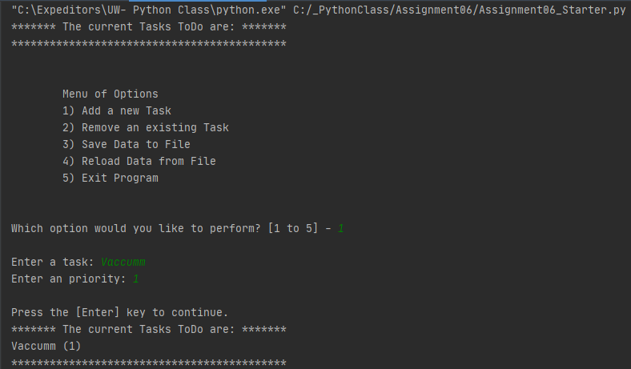

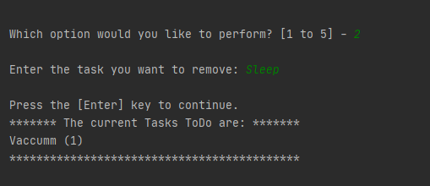 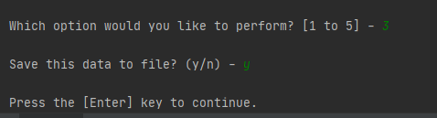 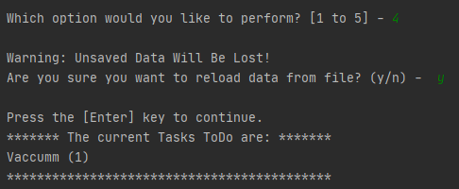

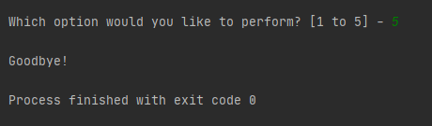

***Fig 1. INPUT- screenshot of code in PyCharm***

For unknown reasons my code would not compile in the command prompt. I kept getting the error below.

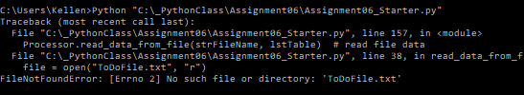

***Fig 2. INPUT- screenshot of code in the Command Prompt***

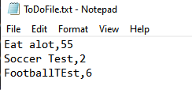

***Fig 3. OUTPUT screenshot of code in the text file.***

# Conclusion

Functions are useful to store important variables and data. And can be called up and used at any point in a python script. These separated “task” can be broken out into procedures to help break up a script. This is especially useful for larger scripts. Return values are needed to return a piece of data that was collected or manipulated by the user. For this assignment I was able to test the functions one at a time and then put them all together. The Reload data from file feature was tested by opening the txt file changing the data, then saving it and running the scrip and selecting open 4.